Is the regeneration of Temple Quarter achieving its vision?
Name: Geography Class:
Introduction
Temple Quarter is an Enterprise Zone in Bristol, as shown on the map below. It used to be a successful industrial area, but when the city centre docks shut it fell into decline.
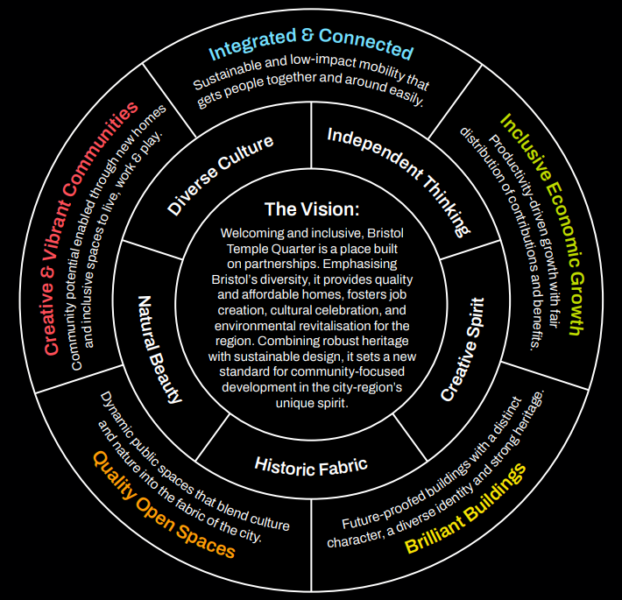
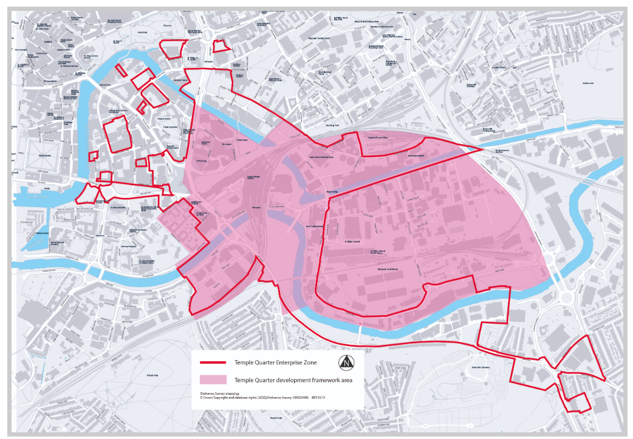
Temple Meads Station
Site 1: Albert Road
Site 3: Feeder Road
Site 2: Paintworks
Site 4: Temple Quay
The vision for the regeneration is:
‘Welcoming and inclusive, Bristol Temple Quarter is a place built on partnerships. Emphasising Bristol’s diversity, it provides quality and affordable homes, fosters job creation, cultural celebration, and environmental revitalisation for the region. Combining robust heritage with sustainable design, it sets a new standard for community-focused development in the city-region’s unique spirit.’
This is reflected in the Vision Compass shown here.
It is an ideal location for us to study regeneration as:
- It is still being regenerated, so we can visit areas which have been regenerated and those that haven’t
- We can travel there easily and sustainably by train or bus during the school day
- The site is small enough that we can visit quite a lot of it in a few hours
We will find out if Temple Quarter’s regeneration is achieving its vision by testing three hypotheses:
Hypothesis 1: Regenerated areas will be cleaner than areas which haven’t been regenerated. Clean areas are a sign that an area’s built and natural environment is being cared for.
Hypothesis 2: Regenerated areas will be more accessible than areas which haven’t been regenerated. Accessibility is an important part of being inclusive and connected.
Hypothesis 3: Regenerated areas will have fewer empty buildings, a wider range of land use and more ‘brilliant buildings’ than in areas that haven’t been regenerated. Buildings in use in a range of ways indicate an area is mixed use and is thriving economically.
Data collection
We will visit four areas to investigate these hypotheses, as shown on the map on page 1. Two of these areas have been regenerated and two haven’t.
We will collect primary data so that we can test these hypotheses:
- Cleanliness Survey – We will give each area a score from 0 to -5 to show how clean it is. We will also note any useful information which could explain the cleanliness.

- Accessibility Index
  - We will complete a bi-polar survey to see how accessible each area is.
  - We will also take photographs showing positive and negative features in relation to accessibility, using what3words to geolocate each photograph.

- Land use Transect -We will complete a transect for 100 paces in each area, recording the land use on each side every 20 paces. We will photograph ‘brilliant buildings’.
We will also collect secondary data by looking online to see how well each area is connected by public transport. This will help us answer hypothesis 2.
We need to be aware of potential risks during our data collection;
Risk | What could happen? | How can we prevent this?
Missing a train

Being injured by a car

Getting lost

Data interpretation
Hypothesis 1: Regenerated areas will be cleaner than areas which haven’t been regenerated.
_____________________________________________________________
_____________________________________________________________
_____________________________________________________________
_____________________________________________________________
_____________________________________________________________
_____________________________________________________________
_____________________________________________________________
Hypothesis 2: Regenerated areas will be more accessible than areas which haven’t been regenerated, showing that areas are inclusive and connected.
_____________________________________________________________
_____________________________________________________________
_____________________________________________________________
_____________________________________________________________
_____________________________________________________________
_____________________________________________________________
_____________________________________________________________
Hypothesis 3: Regenerated areas will have fewer empty buildings, a wider range of land use and more ‘brilliant buildings’ than in areas that haven’t been regenerated.
_____________________________________________________________
_____________________________________________________________
_____________________________________________________________
_____________________________________________________________
_____________________________________________________________
_____________________________________________________________
Conclusion: Is the regeneration of Temple Quarter achieving its vision?
_____________________________________________________________
_____________________________________________________________
_____________________________________________________________
_____________________________________________________________
_____________________________________________________________
_____________________________________________________________
_____________________________________________________________
Evaluation
What are the limitations of the data we collected?
_____________________________________________________________
_____________________________________________________________
_____________________________________________________________
_____________________________________________________________
_____________________________________________________________
How does this affect the reliability of our conclusions?
_____________________________________________________________
_____________________________________________________________
_____________________________________________________________
_____________________________________________________________
How could we improve this investigation?
_____________________________________________________________
_____________________________________________________________
_____________________________________________________________
____________________________________________________________

