Is the regeneration of Temple Quarter achieving its vision?
Name: Geography Class:
Hypothesis 1: Regenerated areas will be cleaner than areas which haven’t been regenerated
Primary data collection 1: Cleanliness survey
We will visit four parts of Temple Quarter – two which have been regenerated and two which haven’t. Use the index below to assess the cleanliness of these four locations.
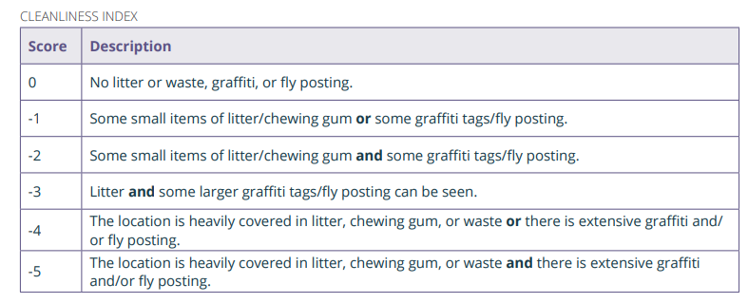
At each sample point:
- Record the geo-location (use what3words) and the time you made the observation.
- Give a score between 0 and -5.
- Use the final column of the table to make a note about the location. Is there anything in this location that might explain the amount of litter or waste, such as a nearby street market, takeaway or bus stop?
Geo-location (what3words) | Time | Score | Notes
Albert Road
Paintworks
Feeder Road
Temple Quay
Hypothesis 2: Regenerated areas will be more accessible than areas which haven’t been regenerated
Primary data collection technique 2: Accessibility Index
- Complete a bipolar survey for each of the four locations.
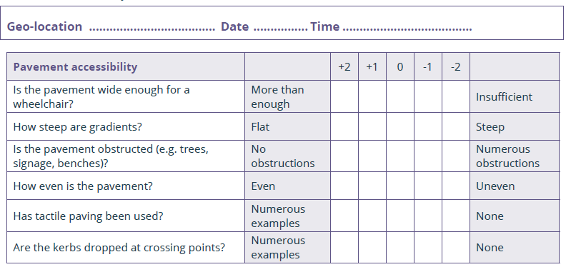
Primary data collection technique 3: Located photographs
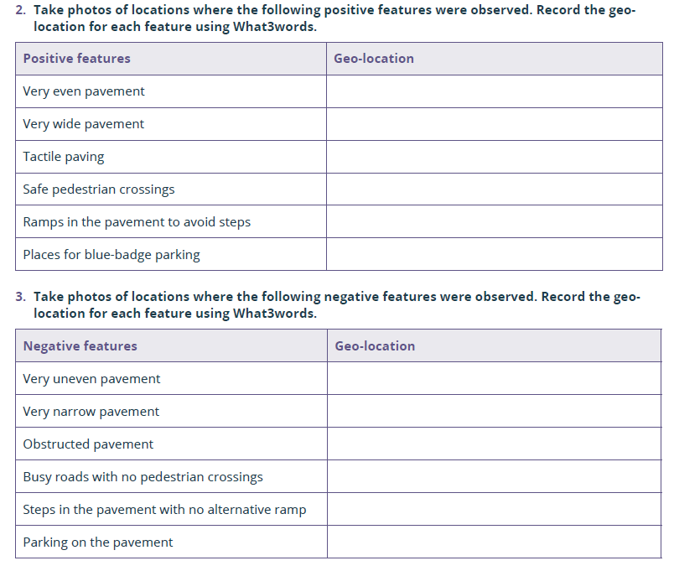

Hypothesis 3: Regenerated areas will have fewer empty buildings, a wider range of land use and more ‘brilliant buildings’ than in areas that haven’t been regenerated.
Primary Data Collection Technique 4: Land use transects
Walk through each of the 4 areas for 100 paces, noting down how the land is being used on each side every 20 paces. Record your findings in the grids below. Take photos of ‘brilliant buildings’
Location:
Land use to your left |  | Land use to your right
 | Road or path
Location:
Land use to your left |  | Land use to your right
 | Road or path
Location:
Land use to your left |  | Land use to your right
 | Road or path
Location:
Land use to your left |  | Land use to your right
 | Road or path

