Is the regeneration of Temple Quarter achieving its vision?
Name: Geography Class:
Hypothesis 2: Regenerated areas will be more accessible than areas which haven’t been regenerated
Complete the radar graphs below to show the results of your accessibility surveys
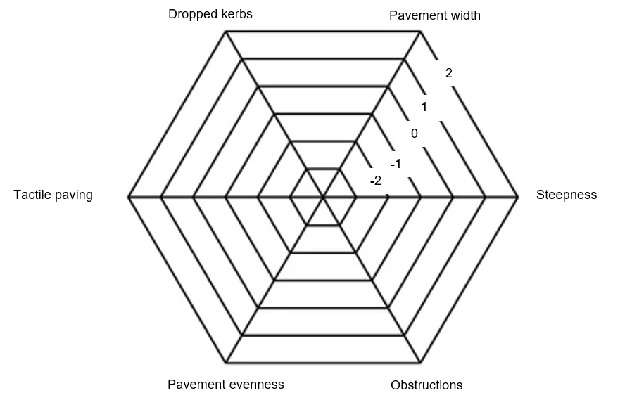
Location 1: Albert Road
Location 2: Paintworks
Location 3: Feeder Road
Location 4: Temple Quay
Why are radar graphs a good data presentation technique to use to show this data?
____________________________________________________
____________________________________________________

What do these graphs show us about the accessibility of the different areas?
____________________________________________________
____________________________________________________

Does this information suggest that hypothesis 2 is true or false? Why?
____________________________________________________

